* Below are details of Upload browserweb,TAFJ & TWS war from devops m/c to nexus & downloading same in Jenkins & deployed using UCd
* Solution architecture

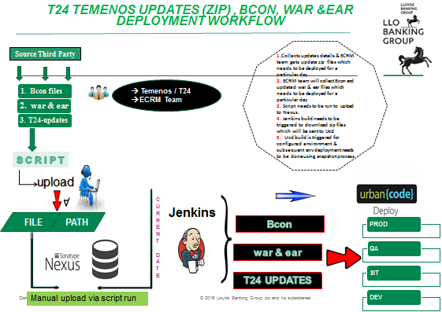

Uploading steps:

1. Remove previous files if any under **/t24/delbuild/thirdparty/browserweb_wars**
2. Remove previous files if any under **/t24/delbuild/thirdparty/TAFJear**
3. Remove previous files if any under **/t24/delbuild/thirdparty/tws_war**
4. Place browserweb war files under **/t24/delbuild/thirdparty/browserweb_wars** directory.

* Files must be in .war format

1. Place tws war files under **/t24/delbuild/thirdparty/TAFJear** directory.

* Files must be in .ear format

1. Place tws war files under **/t24/delbuild/thirdparty/tws_war** directory

* Files must be in .war & .ear format

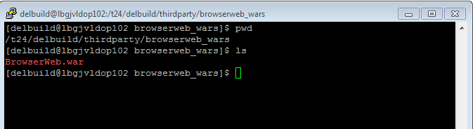

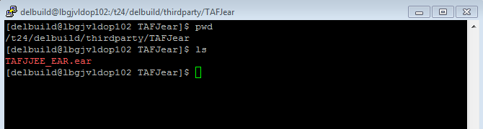

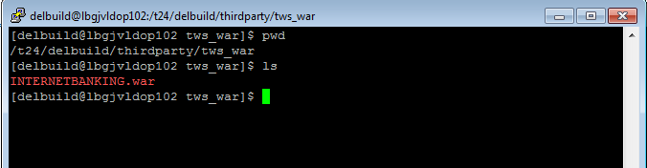

**Note:**

* Files must be in .war & .ear format
* You must need to wipe out prior deployed ones, so as to consider fresh T24Updates zip files.

1. Go to **/t24/delbuild/thirdparty/Scripts** and run **./upload_browserweb_war_file_to_nexus.ksh** scripts.

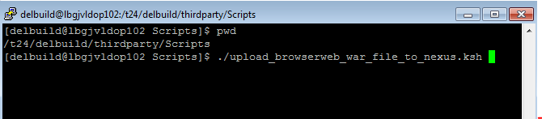

**./upload_TAFJear_file_to_nexus.ksh**

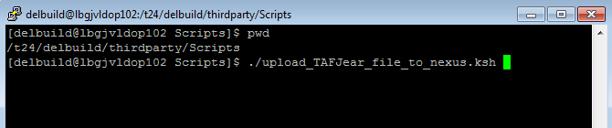

**./upload_TWS_war_to_nexus.ksh**

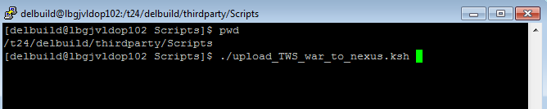

1. Post run, you can have a look at Nexus : you can see on current date folder

<http://172.27.194.36:8081/nexus/#view-repositories;releases~browsestorage>

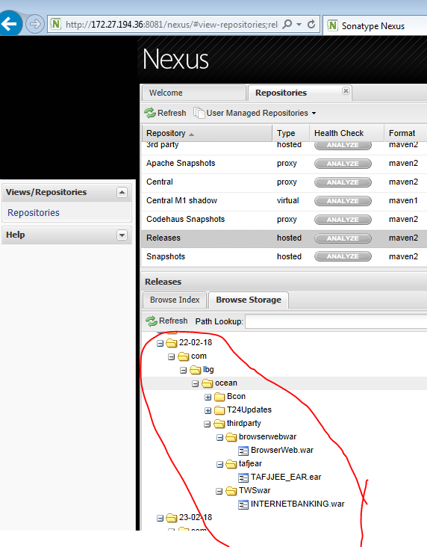

**NOTE:**

* You should run Jenkins job on the same day, when you upload files into nexus by using script

(Jenkins job looks for current date)

* Overwrite functionality is not supported in Nexus under same release build folder. Remove from nexus or reach to DevOps team

**Jenkins steps:**

**push-browserweb-to-UCD:**

* This job will push browserweb war into Ucd

http://172.27.194.36:9200/job/push%20artefacts/job/push-browserweb-to-UCD/

* Click on above link it will redirect to Jenkins job
* Click on build now

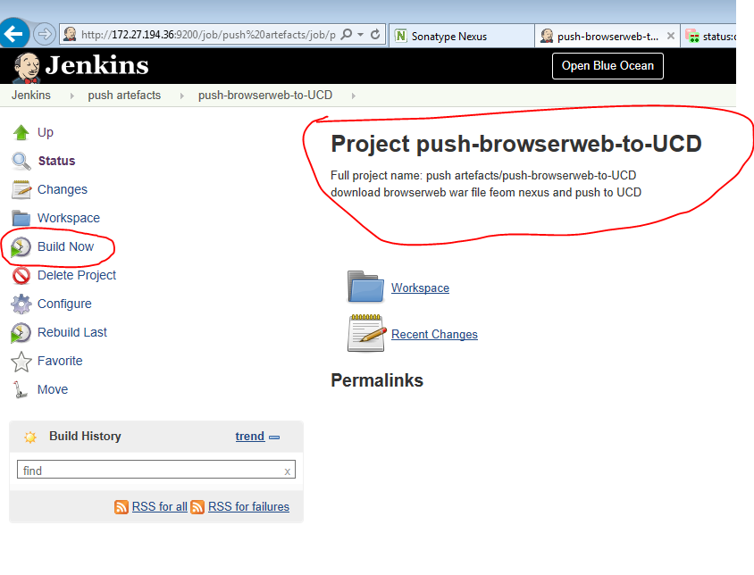

**push-TAFJear-to-UCD:**

* This job will push TAFJear file into Ucd

http://172.27.194.36:9200/job/push%20artefacts/job/push_tafj_ear_to_UCD/

* Click on above link it will redirect to Jenkins job
* Click on build now

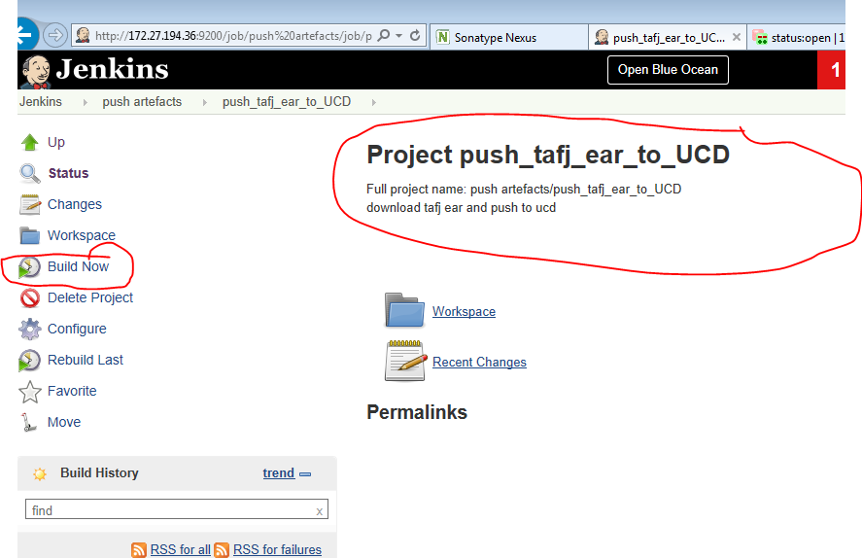

**push-TWS_WAR-to-UCD:**

* This job will push tws war into Ucd

http://172.27.194.36:9200/job/push%20artefacts/job/push_TWS_war_to_UCD/

* Click on above link it will redirect to Jenkins job
* Click on build now

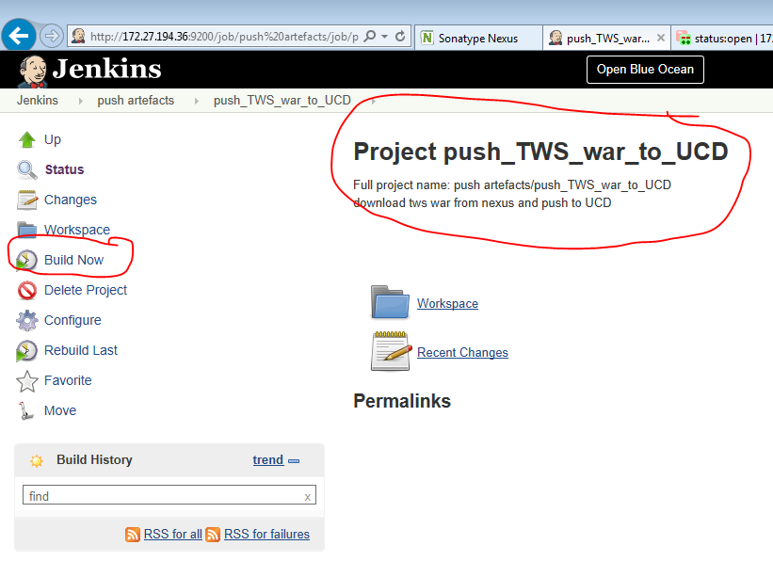

**Ucd steps:**

Go to Below link

<https://ucd.intranet.group/#application/865cc0af-2f37-4dd6-aa37-25816de1053f>

**login with fileId and password**

you can see below screen shot

1. Select environment where you want to deploy and click on play button (see below screen shot no.1)
2. if it is **prod or preprod (cluster)** select process **( Ocean - Dual Cluster - Install Apps Only)**

**NOTE**: if it **single server environment** Select the process **(Ocean - Single Server - Install Apps Only)**

1. Click on choose versions
2. Click on Add button and select **latest version (select 3 components browserweb,TAFJear & TWS war)**

* (if you not uploaded to nexus , then wont select version)

1. Click **Ok**
2. Click on **submit**

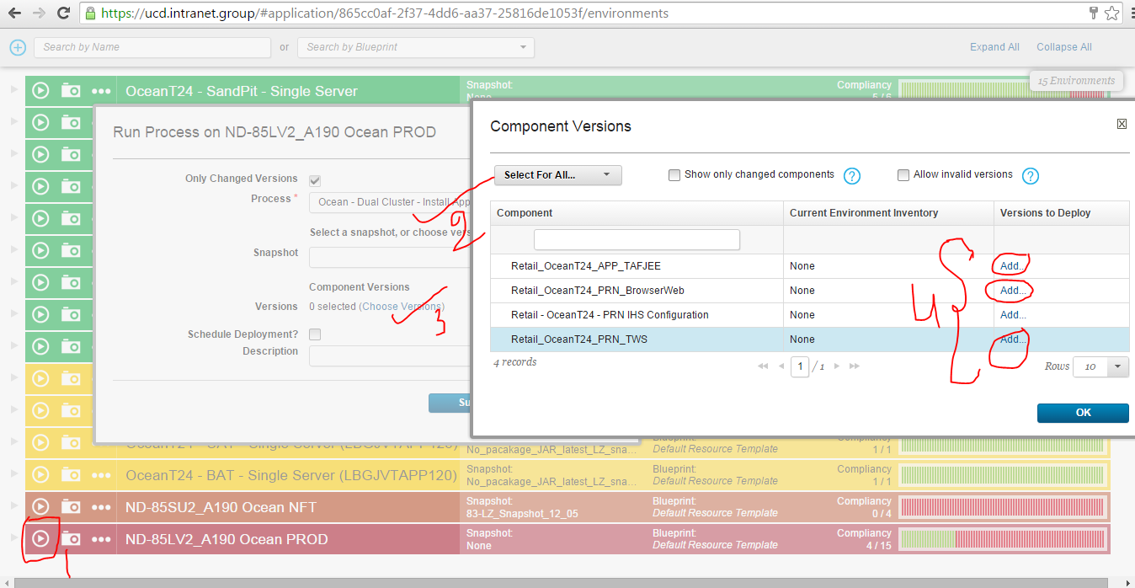

* It went for approval ask to person to accept who have approve privilege